

University of Petroleum &

Energy Studies

# SCHOOL OF COMPUTER SCIENCE

**Name**: Akshat Agarwal **Course**: BTech CSE **SAP ID**: 500118953

**BATCH**: 1

**PRESENTED TO**: Dr. Syed Sajid Hussain

**Semester**: 3

# Experiment 14: To understand the concepts of function and procedure in PL/SQL.

**Objective:** Students will be able to implement the Pl/SQL programs using function and procedure.

* **Implement the above experiments of PL/SQL using functions and procedures.**
  1. **Write a PL/SQL code to accept the value of A, B & C display which is greater.**

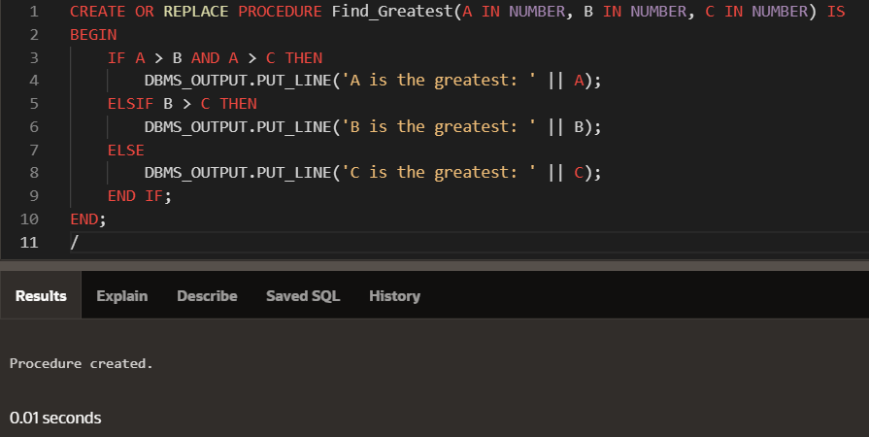**INPUT:**

**OUTPUT:**

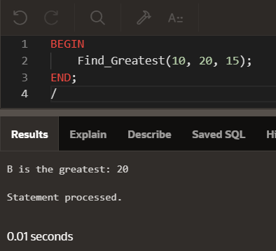

* 1. **Using PL/SQL Statements create a simple loop that display message “Welcome to PL/SQL Programming” 20 times.**

**INPUT:**

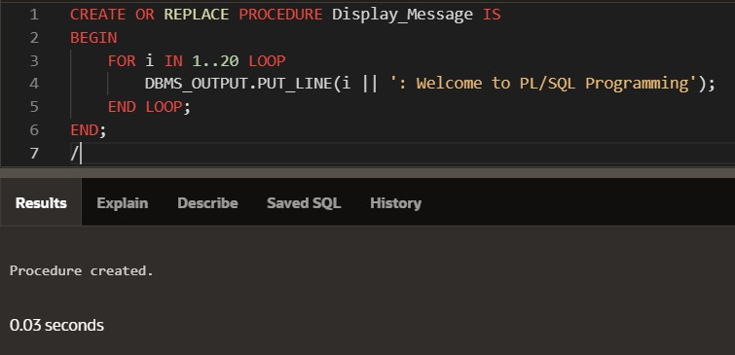

**OUTPUT:**

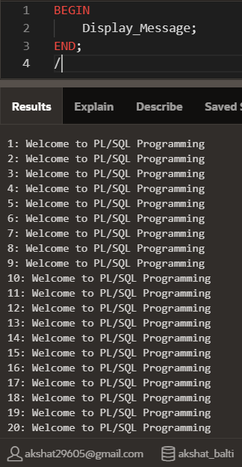

* 1. **Write a PL/SQL code block to find the factorial of a number. INPUT:**

Using Function:

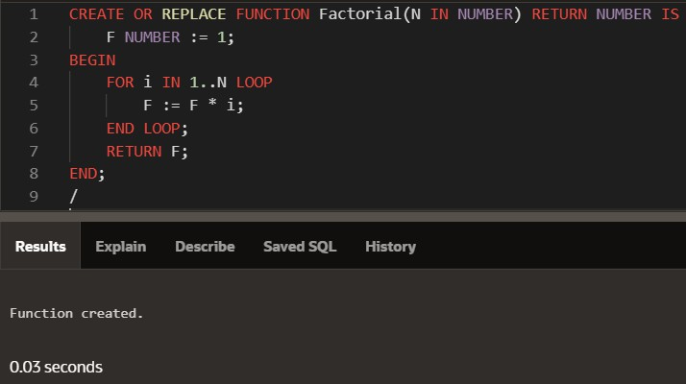

Using Procedure:

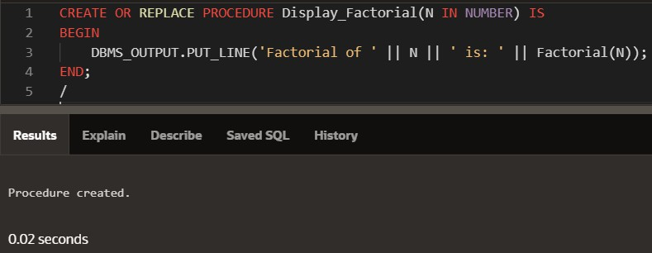

**OUTPUT:**

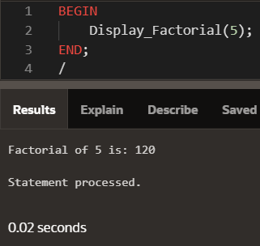

* 1. **Write a PL/SQL program to generate Fibonacci series. INPUT:**

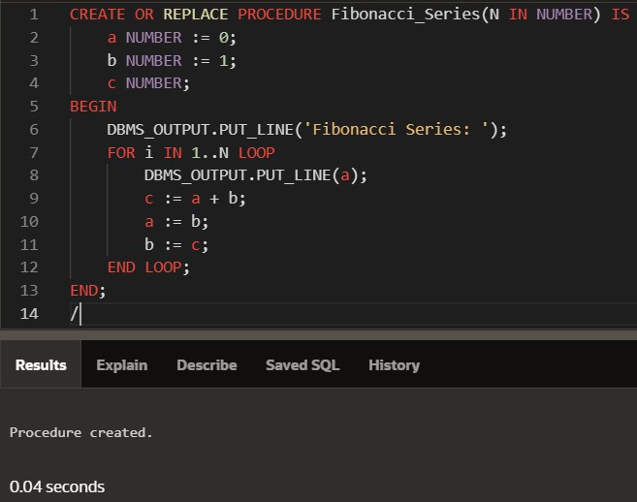

**OUTPUT:**

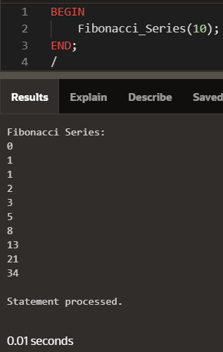

* 1. **Write a PL/SQL code to fund the sum of first N numbers INPUT:**

Using Function:

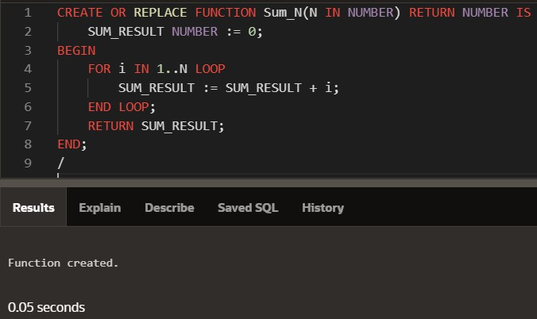

Using Procedure:

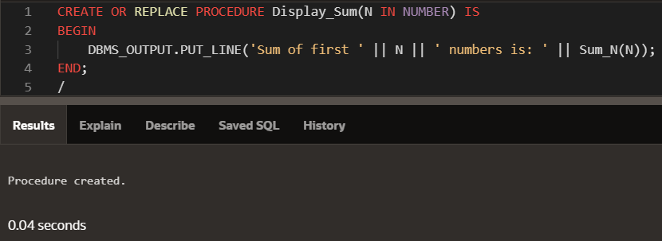

**OUTPUT:**

